Kickstarter Analysis Summary

Eyamba D. Bokamba

U of M Data Visualization & Analytics Boot Camp

11/17/18

**What are three conclusions we can make about Kickstarter campaigns given the provided data?**

Conclusions:

* Far more plays request funding via Kickstarter and are successful
  + i.e. plays are more likely to get funding than any other sub-category of campaign
  + 65% of all plays were successful
* More campaigns succeed than fail, but it is almost a 50/50 chance of success.
  + Approximately 53% success rate over all.
* Over time the number of successfully funded campaigns seems to be decreasing, while those that fail or are cancelled seems to remain flat.

**What are some of the limitations of this dataset?**

Limitations:

* There may be missing data or conversion errors based on different international currency
* Can we trust the data sources? Where is this information coming from?
  + Multiple sources vs. single?

**What are some other possible tables/graphs that we could create?**

* It would be nice to also see each table with results represented as a percentage of the grand total.

|  |  |  |  |  |  |
| --- | --- | --- | --- | --- | --- |
| country | (All) |  |  |  |  |
| Category | (Multiple Items) |  |  |  |  |
|  |  |  |  |  |  |
| **Count of state** | **Column Labels** |  |  |  |  |
| **Row Labels** | **canceled** | **failed** | **live** | **successful** | **Grand Total** |
| animation | 0.00% | 2.43% | 0.00% | 0.00% | 2.43% |
| art books | 0.49% | 0.00% | 0.00% | 0.00% | 0.49% |
| audio | 0.58% | 0.00% | 0.00% | 0.00% | 0.58% |
| children's books | 0.00% | 0.97% | 0.00% | 0.00% | 0.97% |
| classical music | 0.00% | 0.00% | 0.00% | 0.97% | 0.97% |
| documentary | 0.00% | 0.00% | 0.00% | 4.38% | 4.38% |
| drama | 0.00% | 1.94% | 0.00% | 0.00% | 1.94% |
| electronic music | 0.00% | 0.00% | 0.00% | 0.97% | 0.97% |
| faith | 0.00% | 0.97% | 0.49% | 0.00% | 1.46% |
| fiction | 0.00% | 0.97% | 0.00% | 0.00% | 0.97% |
| food trucks | 0.49% | 2.92% | 0.00% | 0.00% | 3.40% |
| gadgets | 0.00% | 0.49% | 0.00% | 0.00% | 0.49% |
| hardware | 0.00% | 0.00% | 0.00% | 3.40% | 3.40% |
| indie rock | 0.00% | 0.49% | 0.00% | 3.40% | 3.89% |
| jazz | 0.00% | 1.46% | 0.00% | 0.00% | 1.46% |
| makerspaces | 0.00% | 0.27% | 0.00% | 0.22% | 0.49% |
| metal | 0.00% | 0.00% | 0.00% | 0.49% | 0.49% |
| mobile games | 0.00% | 0.97% | 0.00% | 0.00% | 0.97% |
| musical | 0.49% | 1.46% | 0.00% | 1.46% | 3.40% |
| nature | 0.00% | 0.49% | 0.00% | 0.00% | 0.49% |
| nonfiction | 0.00% | 0.00% | 0.00% | 1.46% | 1.46% |
| people | 0.00% | 0.49% | 0.00% | 0.00% | 0.49% |
| photobooks | 0.00% | 1.39% | 0.00% | 2.50% | 3.89% |
| places | 0.00% | 0.49% | 0.00% | 0.00% | 0.49% |
| plays | 0.00% | 8.58% | 0.46% | 16.87% | 25.91% |
| pop | 0.00% | 0.00% | 0.00% | 0.97% | 0.97% |
| radio & podcasts | 0.00% | 0.00% | 0.00% | 0.49% | 0.49% |
| restaurants | 0.00% | 0.49% | 0.00% | 0.00% | 0.49% |
| rock | 0.00% | 0.00% | 0.00% | 6.32% | 6.32% |
| science fiction | 0.97% | 0.00% | 0.00% | 0.00% | 0.97% |
| shorts | 0.00% | 0.00% | 0.00% | 1.46% | 1.46% |
| small batch | 0.00% | 0.00% | 0.15% | 0.83% | 0.97% |
| space exploration | 0.44% | 0.05% | 0.00% | 0.97% | 1.46% |
| spaces | 0.41% | 1.94% | 0.12% | 2.07% | 4.55% |
| tabletop games | 0.00% | 0.00% | 0.00% | 1.94% | 1.94% |
| television | 0.00% | 0.00% | 0.00% | 1.46% | 1.46% |
| translations | 0.24% | 1.14% | 0.00% | 0.00% | 1.39% |
| video games | 0.00% | 2.43% | 0.00% | 0.00% | 2.43% |
| wearables | 1.46% | 2.92% | 0.00% | 0.49% | 4.86% |
| web | 2.43% | 1.46% | 0.00% | 0.00% | 3.89% |
| world music | 0.49% | 0.00% | 0.00% | 0.00% | 0.49% |
| **Grand Total** | **8.48%** | **37.19%** | **1.22%** | **53.11%** | **100.00%** |

* Seeing State represented as percentage of the grand total filtered by country would be interesting. It may allow us to work on a model to predict funding behavior depending on location.

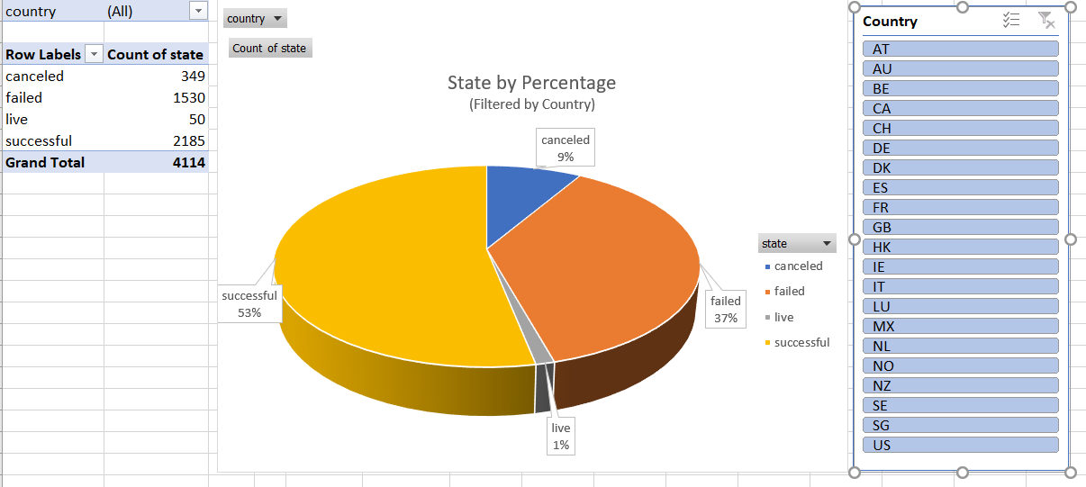

* Visually it would be nice to see a map that demonstrates number of campaigns and the status/state. In Excel this doesn’t seem possible while using pivot charts. Another program, such as Tableau or Power BI would be useful here.